**Gautrain and Avis Car Hire**

**15% discount campaign**

**Terms and Conditions**

1. The 15% discount is valid between 15 September 2023 and 31 December 2023
2. Applicable to the Avis Gautrain Sandton Station branch, Avis Midrand Grand Central Airport branch and Avis Centurion Barloworld Toyota only
3. Promotion is valid for Gautrain commuters providing a valid Gautrain Swift Card** upon signing a contract to rent a vehicle from the participating Avis branches
4. The offer applies to the best available rate of the day
5. The offer will only be applicable to rentals where a passenger has made use of the train on the date of the car rental or if Chauffeur services are required
6. Customers do not need to book their vehicle upfront to qualify for the discount – walk-ins are welcome
7. Limited to 1 (one) rental per month
8. Once the discount has been redeemed, it is not transferable for any other vehicle or service
9. The offer is not redeemable for cash or alternatives
10. This discount does not apply with any other discounts, promotions or specials
11. Avis has the right to remove this offer at any time, and without prior notice. The management’s decision is final and binding
12. Gautrain does not take any responsibility for the quality of the products and/or services offered by Avis
13. Gautrain reserves the right to withdraw, postpone, amend, or suspend this promotion at any time and for any reason which may be deemed necessary, without prior notice
14. Gautrain and Avis comply with provisions of the Consumer Protection Act 68 of 2008 (CPA) and the Protection of Personal Information Act 4 of 2013 (POPIA)

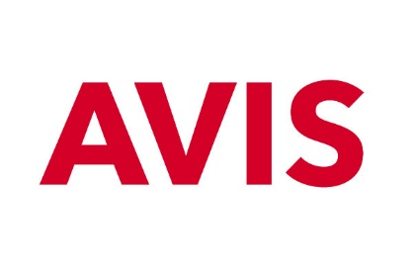

*\*\*Valid Gautrain Swift Card means a Gautrain card which has not yet reached its expiration date as indicated on the bottom right corner of the card*

**CUSTOMER QUERIES**

AVIS/car rental:

* AVIS website: [Gautrain - Affordable Car Rental | Avis Rent a Car](https://eur02.safelinks.protection.outlook.com/?url=https%3A%2F%2Fwww.avis.co.za%2Fdrive-avis%2Ftravel-partners%2Fgautrain&data=05%7C01%7Celsabeh%40Gautrain.co.za%7C2001aff205944d9744c508dbb535c3d0%7Ca52dec94765640299b2bf41464856796%7C1%7C0%7C638303014776547941%7CUnknown%7CTWFpbGZsb3d8eyJWIjoiMC4wLjAwMDAiLCJQIjoiV2luMzIiLCJBTiI6Ik1haWwiLCJXVCI6Mn0%3D%7C3000%7C%7C%7C&sdata=DebtbC2eP5qW1amJM5YTThg3SoUgDDGgIysNls7H4vk%3D&reserved=0)
* Customer call centre: 0800 001 669 / +27 11 387 8432

Gautrain operational:

* Customer call centre: 0800 Gautrain (0800 428 87246)